Year 8 Science EXAM REVISION – Term 2 – Rocks

Complete the following questions in your notebooks, using your notes and textbooks

- Label the diagram of the Earth’s layers below:

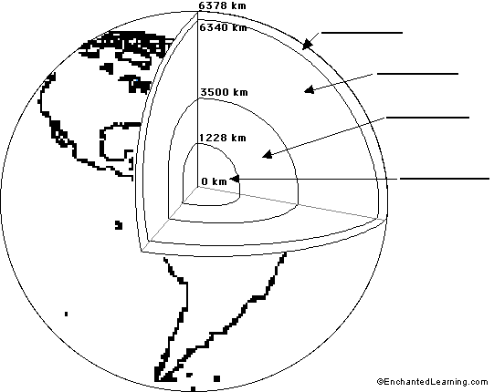

- Explain the difference between ‘minerals’ and ‘rocks’.

- Minerals have six main properties and all are contained in the list of twelve properties below. Identify the six properties which are used to identify minerals.

- Brightness
- Lustre
- Streak
- Rigidity
- Cleavage
- Fracture
- Clarity
- Hardness
- Density
- Texture
- Odour
- Colour

- Explain the difference between magma and lava.

- Identify which type of rock (igneous, sedimentary or metamorphic) is being described by each statement below:

- has layers __________________
- has pebbles all cemented together __________________
- has distinct interlocking crystals __________________
- formed by cooling molten magma __________________
- formed by changing existing rocks with heat and pressure __________________
- may contain fossils __________________

- Explain the relationship between cooling rate of molten rock and crystal size.

- Explain how you can tell the difference between an intrusive and an extrusive igneous rock>

- a) What is a fossil?
b) How are fossils formed?
- Complete the table below to summarise the three types of rocks:

TYPE OF ROCK | HOW ARE THEY FORMED? | What makes this rock look different from the other two types of rocks
Igneous
Sedimentary
Metamorphic

- Explain which type(s) of rock you would expect to find fossils in, and which type(s) you would not expect to find fossils in.

- a) Define the term ore

- Classify the following rocks as either Igneous, Sedimentary or Metamorphic:
- Shale e) Basalt
- Granite f) Conglomerate
- Mudstone g) Pumice
- Marble h) Slate

- There are six substances or objects mentioned in the list below. Use the information in the list to put the six substances mentioned (in italics) in order from hardest to softest:

- A steel file can scratch a pen knife blade
- Calcite scratches a copper coin
- A pen knife blade scratches calcite
- Quartz can leave a mark on a steel file
- Quartz is scratched by topaz

- An opal miner has been keeping records of the depth of her mine and the total number of opals which have been found in the mine. The data is shown in the table below:

Mine depth (m) | number of opals found
15 | 15
20 | 40
25 | 75
30 | 90
35 | 120
40 | 130
45 | 135
50 | 139

a) Use the information in the table below to plot a line graph:



b) State the independent variable.

c) State the dependent variable.

d) Write a conclusion about the information shown in the graph. Be as detailed as
possible.

- Complete the diagram of the rock cycle below:
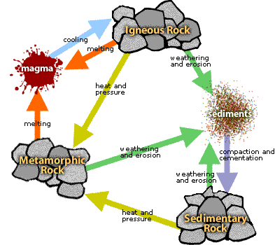

- Identify which type of rocks (igneous, sedimentary, or metamorphic) would take the longest to form, and explain why.

